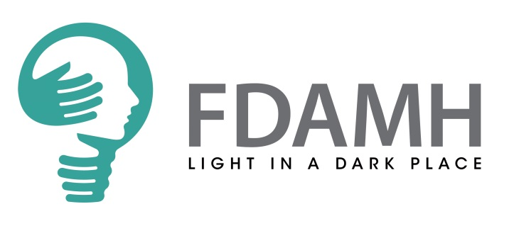

TRUSTEE APPLICATION FORM
Confidential
Please complete this application form and send to: morag.fullard@fdamh.org.uk
Name
Home Address including post code

Telephone | Home |  | Mobile
E-mail
Occupation
Qualifications
Please indicate why you want to become a Trustee of FDAMH and how you think your own skills and experience would enable you to fulfil the role of a Trustee and be of benefit to the organisation as described in the role description (500 words max).

What skills and experience can you bring to our Board?

It’s really important to us that members of our board find the role of Trustee rewarding. What do you hope to gain from being a member of our Board?

Referees
Please provide contact details of two people who may be approached for references and who will be able to comment upon your suitability as a Trustee to the Board of Falkirk and District Association for Mental Health. We will request references only if you are selected for interview.
1. | Name:
1. | Address & post code:
1. | Tel: Home: | Work:
1. | Email:
1. | In what capacity, and over what period of time have you known the referee?
2. | Name:
2. | Address & post code:
2. | Tel: Home: | Work:
2. | Email:
2. | In what capacity, and over what period of time have you known the referee?

Data Protection
Any data about you will be held in secure conditions with access restricted to those who need it in connection with your application and the selection process. Data may also be used for the purpose of monitoring the effectiveness of the recruitment process, but in these circumstances, all data will be kept anonymous.
I have read and understood the information above and at this stage do not consider that there are likely to be any impediments to my appointment: Yes ☐ No ☐
Name:
Signed:

Date:

Thank you for taking the time to complete this application. Once we receive it, we will aim to respond to you within 10 working days.

